JSW ONE TMT

STANDARD OPERATING PROCEDURE

POST-ORDER PHASE

Section D - Phase 4: Plant Operations (Dispatch)
Activity | Steps | Team | Interface / Utilities used | Sign off
7. | Receive freight order details generated by Biz-ops. | Plant Operations | ERP
7.a. | Receive system-generated or Zoho-generated DO from JOTS team. | Plant Operations | Plant Portal / Zoho
7.b. | Generate: Invoice (TC - Tax Challan), E-Way Bill for interstate transportation. | Plant Operations | ERP/Zoho
7.c. | Push Invoice Registration Portal (IRP) data and generate E-Way Bill. | Plant Operations | IRP Portal / E-Way Bill System
7.d. | Complete ERP invoice approval process. | Plant Operations | ERP
7.e. | Conduct final dispatch with Tax Challan (TC) documentation. | Plant Operations | Physical + ERP

Note: Original Activity 7.f (GRN & Invoicing Post-Weighment) has been expanded into comprehensive Phase 5 below.

Activity 10: Vehicle Arrival & Weighment Coordination
Activity | Steps | Team | Interface / Utilities used | Sign off
10. | Vehicle Arrival and Weighment: Ensure proper coordination and quality control during vehicle arrival, inspection, loading, and final weighment process. | Plant Operations | Plant Gate System
10.a. | Vehicle Arrival: Plant Ops monitor vehicle arrival at plant. Upon arrival at gate, ensure vehicle completed two weighments outside plant. Direct vehicle to third weighment inside plant. | Plant Operations | Plant Gate, Weighbridge
10.b. | Loading Advice Verification: Loading advice prepared by CM team. JSW ONE staff verify loading advice matches Delivery Order (DO). | Plant Operations | Loading Advice System, DO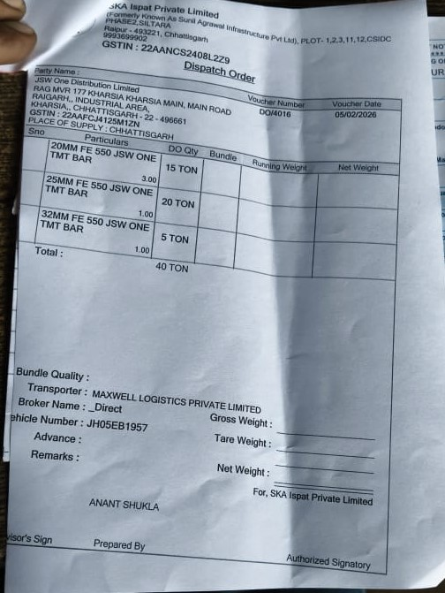
10.c. | Vehicle Inspection (Post Internal Weighment): Conduct thorough inspection: Confirm length sufficient for loading, Ensure vehicle body intact and dry, Verify vehicle equipped with tarpaulin and ropes.  Based on inspection outcome:  • If vehicle passes: proceed with loading  • If vehicle fails: escalate to JOTS  Capture two photos:  • Vehicle number and driver in single frame  • Vehicle body image | Plant Operations | Inspection Checklist, Camera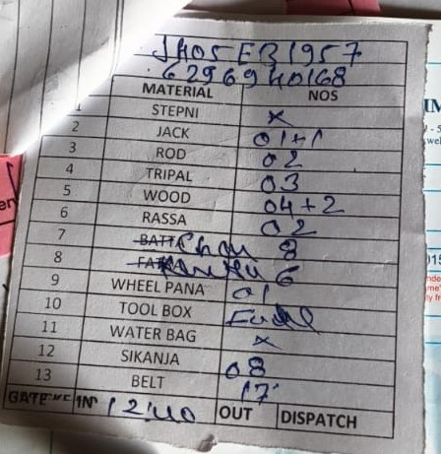

Activity 11: Loading Process Execution
Activity | Steps | Team | Interface / Utilities used | Sign off
11. | Loading Process: Load materials strictly as per the Loading Advice. | Plant Operations | Loading Advice, Weighbridge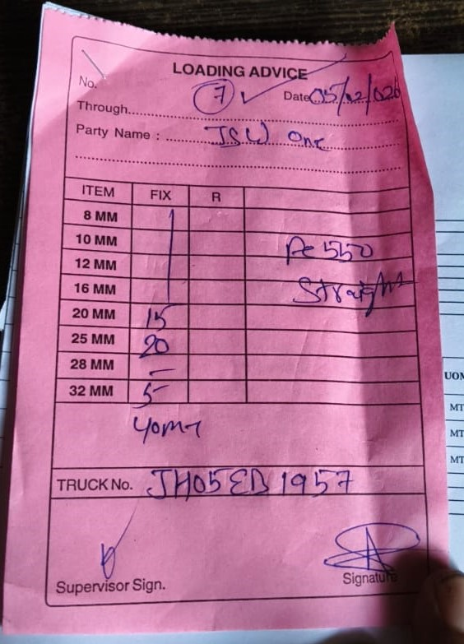
11.a. | Load materials strictly per Loading Advice. Ensure loading done within specified tolerance limits. | Plant Operations | Loading Advice
11.b. | Perform weighment for each SKU loaded. Record weights accurately in system. | Plant Operations | Weighbridge System
11.c. | Post-Loading Steps: After loading, secure material using 5-meter seals. Capture photo of fully loaded and sealed vehicle. Direct vehicle for final weighment. Submit final weighment slip to CM Dispatch Office. | Plant Operations | Sealing Equipment, Camera, Weighbridge, CM Dispatch Office  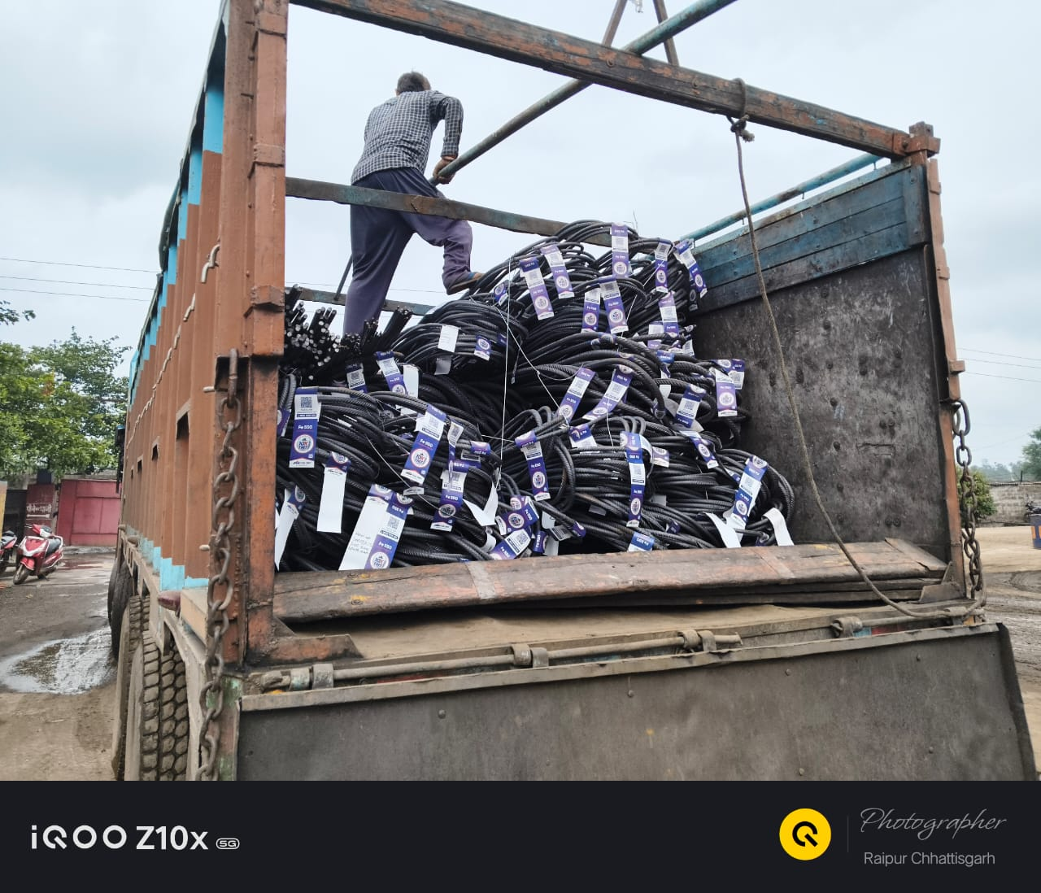
11 D | MTC generation through Zoho after entering material details e.g. Dia, Heat no, Batch no & material quality parameters | Plant Operations | JTR  SGA Test report  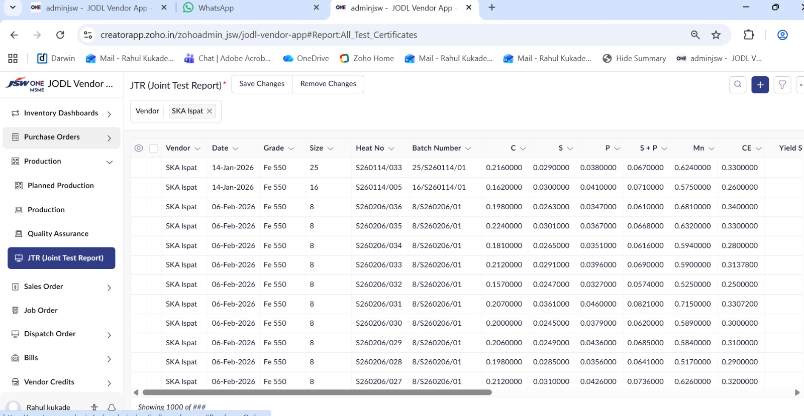
11 D | LR Copy Generation | JOTS | Transporter’s copy  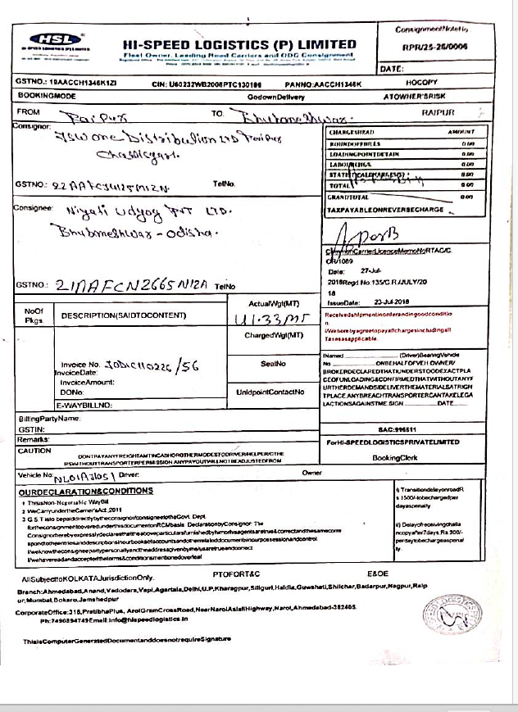
11 E | Handing over documents to Vehicle driver- Invoice, MTC, E-Waybill & LR Copy | Plant Operations | 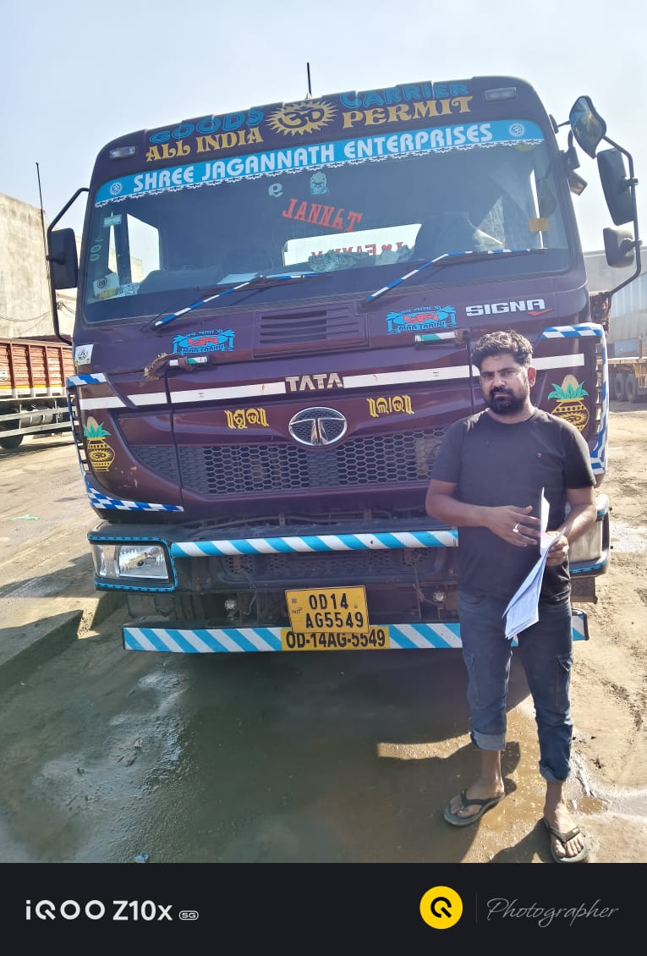

Activity 12: GRN Entry in Zoho Books (PB Plant Ops)
Activity | Steps | Team | Interface / Utilities used | Sign off
12. | GRN & Invoicing Post-Final Weighment: Following successful completion of final weighment after loading process, invoice generation and finalization must begin. | PB Plant Ops | Zoho Books
12.a. | Collect Seller Invoice: PB Plant Ops team must collect seller invoice from CM Dispatch Office. | PB Plant Ops | CM Dispatch Office  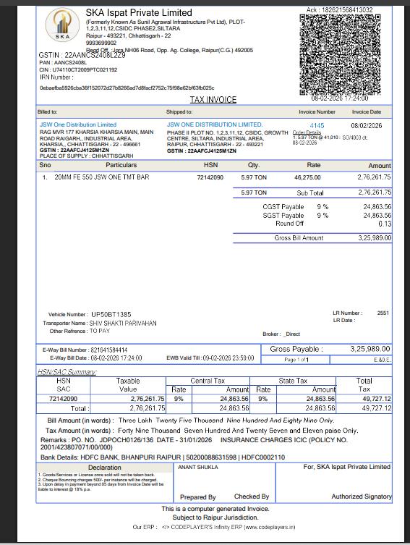
12.b. | Perform GRN in Zoho Books: Upon receiving seller invoice, perform Goods Receipt (GRN) entry in ZOHO.  Path → Zoho books → Purchase → Purchase receives  Accurately input mandatory details:  • Seller Invoice Number  • Sales Reference Number  • Payment Terms  • Purchase Order (PO) Number (mentioned in Seller Invoice)  • Material Form | PB Plant Ops | Zoho Books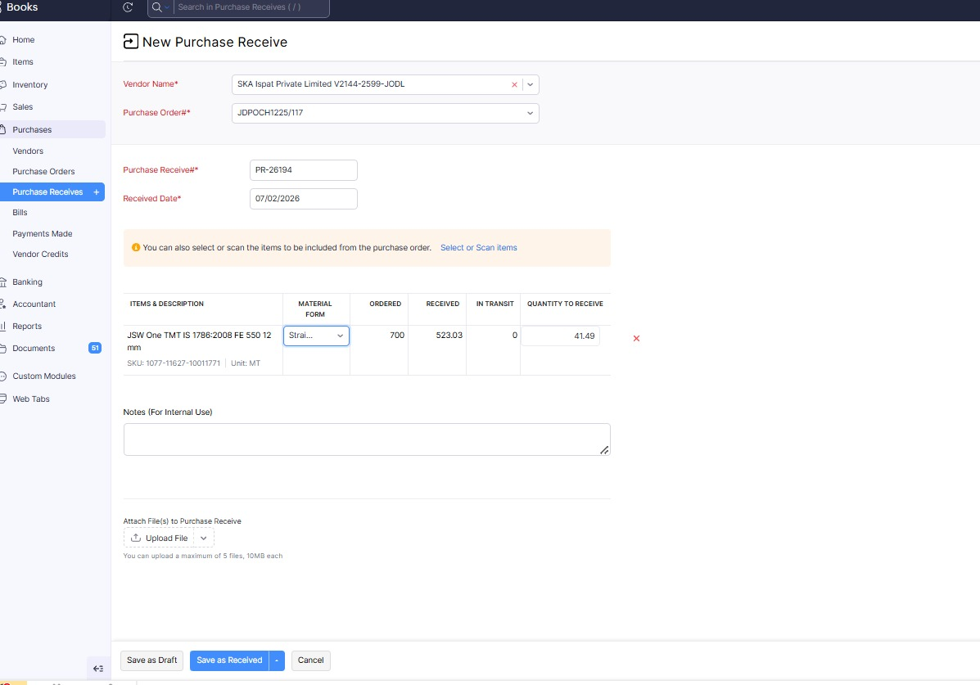
12.c. | Validate GRN vs Seller Invoice: Ensure GRN details strictly match Seller Invoice and Delivery Order (DO). In case of any discrepancies in Seller Invoice, discuss with CM and make corrections before proceeding with GRN entry.  Good receipt sheet Link - GRN Sheet  Once Good receipt done in Zoho, search for sales order associated with order ID. | PB Plant Ops | Zoho Books, GRN Sheet, Seller Invoice  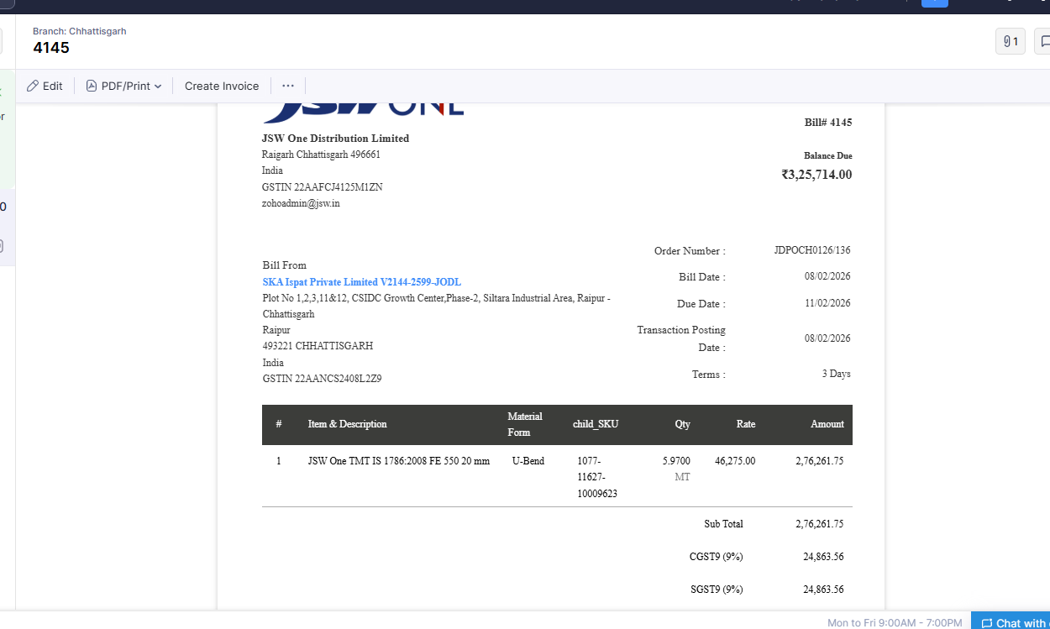

Activity 13: Invoice & E-Way Bill Generation
Activity | Steps | Team | Interface / Utilities used | Sign off
13. | Invoice and E-Way Bill Generation: PB-Plant Ops team responsible for creating Invoice in system and generating E-Way Bill for dispatch.  PB Plant Ops search Sales Order in ZOHO Books to create JODL Invoice against Seller Invoice.  Path – ZOHO Books → Sales → Sales Orders → SO → Convert to Invoice | PB Plant Ops | Zoho Books
13.a. | Create JODL Invoice in Zoho Books: Search Sales Order and convert to invoice in Zoho Books system. | PB Plant Ops | Zoho Books  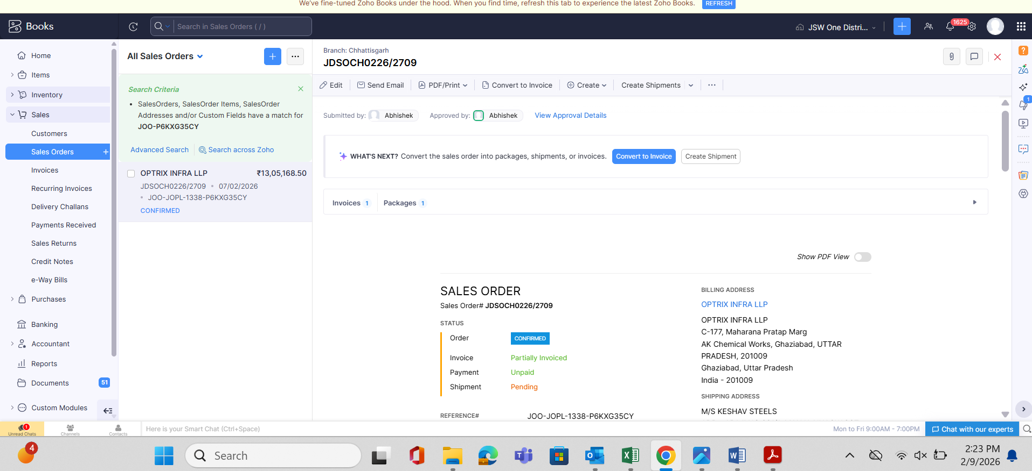
13.b. | Fill Mandatory Bills Section Fields: Following fields must be accurately filled by PB-Ops in Bills Section:  • Dispatch from Address  • Bill to and Ship to addresses – must match GST records  • JODL Invoice Date  • Payment Terms  • Sales Order Reference Number  • Business Segment  • Supply Source  • Incoming Payment details  • E-Commerce (if applicable)  • Payment Mode  • Purchase Bill Reference Number  • E-Way Bill Details: Vehicle Number, Motor Vehicle Number, Mode of Transport (Road to be selected)  • SKU and Quantity – must match Seller Invoice | PB Plant Ops | Zoho Books  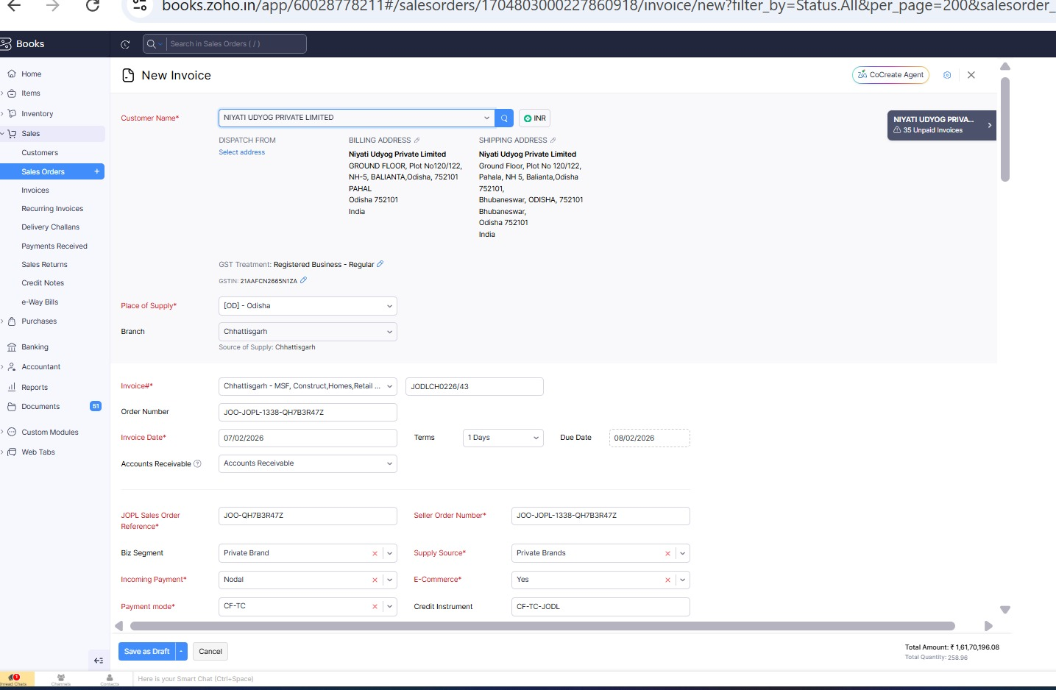
13.c. | IRP Push and E-Way Bill Generation: After submitting invoice, mark "Push to IRP."  Based on invoice value:  • If invoice value > ₹50,000: Push both Invoice and E-Way Bill details to IRP  • If invoice value < ₹50,000: Push only Invoice details to IRP  After pushing to IRP, create E-Way Bill. Enter E-Way Bill details including Vehicle Number and Motor Vehicle Details. Submit E-Way Bill by selecting Push to IRP again for E-Way Bill-specific information.  After successful submission: Select "Mark as Sent" in system. Email invoice to Biz-Ops team for further processing. | PB Plant Ops | Zoho Books, IRP Portal, Email  